**Quick/Summarize Instruction to install**

**CUDA, CUDNN, TensorFlow**

**Date: 2022/02/04**

**By: A. Ghaffari**

* This is the instruction that I found on GitHub and looks reliable and workable. I tried on my Georgian college laptop with:
* Windows 11 pro,
* Intel® UHD Graphics 620 (not compatible to run as GPU)
* GitHub link/links:
* [PratyushTripathy/Land-Cover-Using-Machine-Learning: This repository contains links to resources for land cover classification. (github.com)](https://github.com/PratyushTripathy/Land-Cover-Using-Machine-Learning)
* At the same time watch the video by the GitHub writer for installation, if you need.
* <https://www.youtube.com/watch?v=1G2tkMaoS8Q>
* Follow part 4 at the bottom of the GitHub page:
* 4. Setting up Python, GDAL and TensorFlow

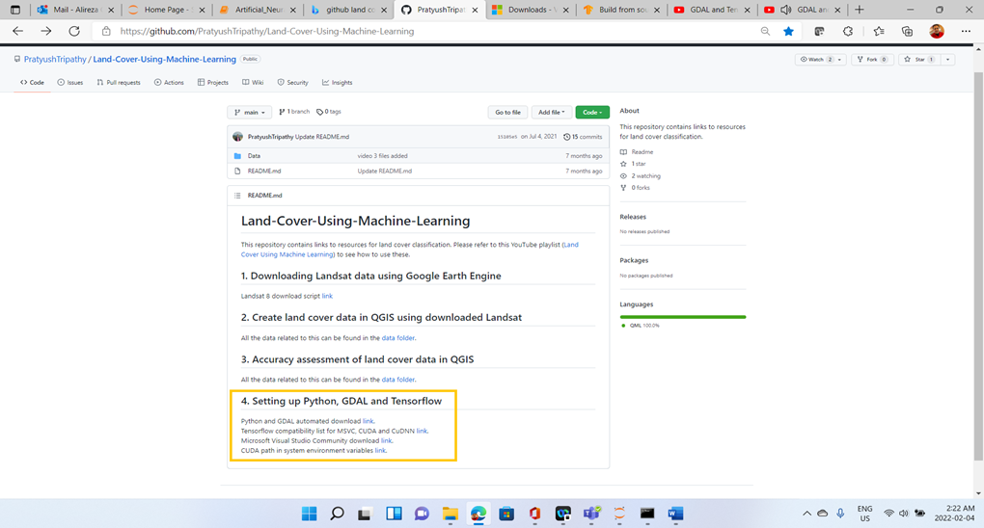

* I followed the instruction and had no errors at all and received successful message for every stage of installation of CUDA, cuDNN, and TensorFlow.
* All configurations done with no issues/errors.
* However, by running this code:
* **tf.test.is_gpu_available()**
* to check the status of GPU
* I got the message show “False” which means the GPU is not running/supporting.
* A screenshot of a computer

  Description automatically generated with medium confidenceFollowing screenshot presenting the result of final stage.
* If your system has Win 10/11 and compatible GPU such as GeForce, you must be able to install and run GPU.
* Please let me know if you could mange to install it on your windows system

Good luck